## horizontal line



Eco-Credits System: Driving Green Behavior

28 JUN .2025

**─**

# Executive Summary

# Problem Statement

# Project Description

# Implementation Plan

# Market Analysis

# Business model and Financial Projection

# Social Impact

# Risk and Mitigation

# Pitching Strategy

# Conclusion and Next Steps

# Key Citations

# 

**1. Executive Summary** **1**

**2. Problem Statement** **1**

**3. Project Description** **1**

**4. Implementation Plan** **1**

**5. Market Analysis** **1**

**6. Business model and Financial Projection** **1**

**7. Social Impact** **1**

**8. Risk and Mitigation** **1**

**9. Pitching Strategy** **1**

**10. Conclusion and Next Steps** **1**

**11. Key Citations** **1**

**Executive Summary** **2**

**Problem Statement** **3**

Background 3

**Project Description** **3**

Case Studies 4

Alignment with Singapore’s Green Plan 2030 4

**Implementation Plan** **4**

Strategic Approach 5

Prototype Functionality 5

User Validation Plan 6

Timeline (24 Weeks) 6

Scalability 6

Stakeholder Benefits 6

Stakeholder Benefits 6

**Market Analysis** **7**

Target Audience and Market Trends 7

Stakeholders and Resources 8

Competitive Advantage 8

**Business Model and Financial Projections** **8**

Revenue Model 8

Financial Projections (3-Year) 8

Funding Ask 9

**Social Impact** **9**

**Risks and Mitigation** **10**

**Pitching Strategy** **10**

**Conclusion and Next Steps** **10**

**Bibliography** **10**

# Executive Summary

The Eco-Credits System (ECS), is a mobile platform designed to reduce carbon emissions in Singapore by incentivizing low-carbon behaviors. Unlike non-profit models like Alipay’s Ant Forest, ECS adopts a profit-driven model for scalability. Aligned with Singapore’s Green Plan 2030, ECS seeks partnerships with the Land Transport Authority (LTA), SP Group, and Huawei to launch a pilot by Q1 2026, delivering measurable environmental and economic impact.

# Problem Statement

Despite growing environmental awareness, Singaporeans lack sufficient incentives to adopt sustainable behaviors consistently, such as opting for public transport over private cars or purchasing eco-friendly products. Current solutions—educational campaigns, non-profit apps, or corporate carbon trading—fall short in engagement, scalability, or precision in tracking individual carbon footprints. This gap hinders citizens from contributing meaningfully to Singapore’s net-zero emissions target by 2050. A scalable, user-friendly system is needed to make sustainability accessible, rewarding, and measurable for individuals.

## **Background**

Personal Carbon Accounts (PCAs) aim to track individual carbon footprints and reward eco-friendly actions, as seen in trials like Norfolk Island and Alipay’s Ant Forest, which incentivizes low-carbon choices (e.g., walking, public transport) with virtual credits for tree planting. However, PCAs face challenges: inaccurate emissions tracking due to diverse lifestyles, high infrastructure costs for scaling, and privacy concerns over behavior monitoring. Non-profit models like Ant Forest lack tangible financial incentives and sustainable funding, limiting their reach.

Carbon trading works for corporations (e.g., cap-and-trade systems) but is too complex and costly for individuals. Research on corporate carbon accounting and urban transport exists, yet there’s a gap in solutions that incentivize individual behavior, link carbon savings to financial rewards, and provide real-time feedback. The Eco-Credits System fills this gap with Huawei’s technology for precise tracking and a profit-driven model for scalability.

# Project Description

The Eco-Credits System (ECS) is a mobile platform that tracks low-carbon actions—public transport use, cycling, walking—and awards users carbon credits redeemable for goods or services from partners like SP Group and NTUC. This integration with essential services makes sustainability financially rewarding, encouraging widespread adoption. Grounded in collective responsibility (individual actions support national net-zero goals) and fairness (accessible to all income levels), ECS uses a profit-driven model to ensure scalability, unlike non-profit predecessors.

## **Case Studies**

* **Ant Forest (China)**: Rewards low-carbon actions with virtual credits for tree planting but lacks financial incentives.
* **Climate Miles (Switzerland)**: Offers points for green commuting, limited by lack of utility integration.
* **KlimaTaler (Germany)**: Provides carbon coins for travel, not scalable beyond local trials.
* **MaaS CO₂ (Japan)**: Tracks mobility emissions but offers no financial rewards.
* **Shanghai Personal Carbon Account Project**: Launched in 2022 in Pudong New District, this initiative allows citizens to earn carbon credits for actions like garbage sorting and energy conservation, exchangeable for financial products via the Tanpuhui platform. It shows government-led potential but lacks ECS’s profit-driven scalability (Reccessary, 2022; Dialogue Earth, 2022).

ECS stands out by combining real-world financial incentives with a scalable, profit-driven approach.

## **Alignment with Singapore’s Green Plan 2030**

Singapore’s Green Plan 2030 targets net-zero emissions by 2050, with goals like 75% public transport usage and 1,300 km of cycling paths by 2030 (Green Plan, 2021). Minister Grace Fu emphasized, “Every Singaporean must be part of this transformation… it is our collective and personal actions that determine the outcome.” ECS aligns by rewarding low-carbon transport choices, supporting citizen engagement in these targets.

# Implementation Plan

## **Strategic Approach**

ECS adopts a profitable PCA model to overcome the barriers highlighted in the above mentioned case studies. We focus on three strategic steps:

* **Government Collaboration (Q3 2025)**: Partner with agencies like LTA, NEA, and NTUC to align with Singapore’s Green Plan 2030, gaining credibility and support. This ensures policy alignment and access to transport data.
* **User Base Development (Q4 2025–Q1 2026)**: Launch the Minimum Viable Product (MVP), onboard volunteers, and iterate based on feedback to build a robust user foundation.
* **Private Sector Partnerships (Q3 2026)**: Collaborate with profit-driven companies to offer incentives, advertise their green initiatives, and generate revenue through fixed payments or revenue-sharing, ensuring financial sustainability.

## **Prototype Functionality**

* **MVP (Months 0–3)**:
  + Mobile app built with Flutter for cross-platform compatibility.
  + Integration with EZ-Link and SimplyGo APIs to track public transport usage automatically.
  + Basic carbon credit calculation based on transport mode (e.g., bus, MRT, cycling) using pre-set emission factors from LTA data.
  + Reward redemption system with QR codes for NTUC e-vouchers or SP Group bill offsets.
* **Advanced Features (Months 4–6)**:
  + **Payment System**: Users link bank accounts and EZ-Link cards for seamless bus/MRT payments via the app, enhancing convenience (similar to digital wallets).
  + **Near-Expiry Store**: A marketplace within the app where users can buy near-expiry goods at discounts using credits or cash, reducing food waste (NEA, 2021).
  + **User Feedback:** Collect user’s response on their experience with the App.
  + Leaderboard and social challenges to boost engagement.

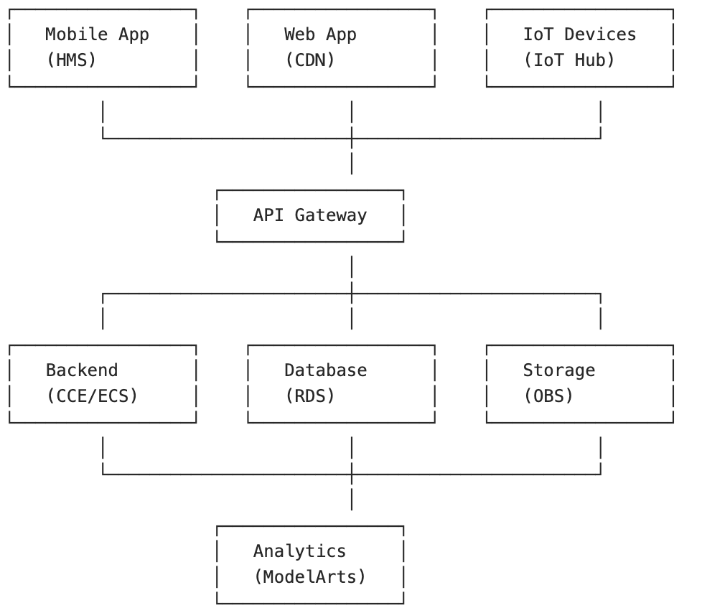

## **User Validation Plan**

* **Beta Testing**: 100 volunteers from SAFRA clubs and educational institutions.
* **Feedback**: Weekly surveys and focus groups to refine UX.
* **KPI**: ≥80% report changing at least one transport habit within 4 weeks.

## **Timeline (24 Weeks)**

* **Q3 2025**: Secure partnerships with LTA, SP Group, NTUC, and other agencies.
* **Q4 2025**: Develop MVP with basic features and payment system integration; onboard volunteers.
* **Q1 2026**: Launch pilot, collect feedback, and introduce advanced features like the near-expiry store.
* **Q3 2026**: Expand private partnerships, scale operations, and enhance features based on user data.

## **Scalability**

* **Technology**: Huawei Cloud FunctionGraph ensures auto-scaling for growing user numbers.
* **Data Standards**: Adheres to Open Mobility Foundation’s Mobility Data Specification for city-wide integration.
* **Partnerships**: Leverages government and private collaborations to expand user base and services.
  + Feasibility:

## **Stakeholder Benefits**

## **Stakeholder Benefits**

* **Government Agencies**:
  + **Policy Alignment**: ECS supports Singapore’s Green Plan 2030, targeting 75% public transport usage by 2030 (Green Plan, 2021).
  + **Data Insights**: Provides anonymized data on transport patterns, aiding LTA’s urban planning.
* **Private Collaborators**:
  + **ECS Label**: Companies display the ECS label, signaling sustainability commitment.
  + **Advertising**: Featured on the ECS app, reaching eco-conscious consumers; 85% of Singaporeans are willing to pay more for sustainable products (SBR, 2022).
  + **CSR Fulfillment**: Supports corporate social responsibility goals, enhancing brand reputation.
* **Users**:
  + **Financial Incentives**: Credits for NTUC e-vouchers or SP bill offsets drive engagement; reward-based programs can increase sustainable behavior by up to 54% (Sustainability, 2024).
  + **Convenience**: Integrated payment system simplifies transport and purchases.
  + **Environmental Impact**: Transparent tracking empowers users to contribute to net-zero goals.

# Market Analysis

### **Singaporeans Are Becoming Increasingly Environmentally Conscious**

## Singaporeans are becoming increasingly environmentally conscious, as reflected in both government initiatives and shifting public behaviors. The Singapore Green Plan 2030, a national framework for sustainability, has garnered broad public support with its clear targets across areas such as energy, transport, waste reduction, and sustainable living. Surveys by the National Environment Agency (NEA) and the Ministry of Sustainability and the Environment indicate a growing number of citizens engaging in eco-friendly practices like recycling, reducing single-use plastics, and seeking out green products. This shift is also evident in transportation habits, with more people opting for MRTs and buses due to improved infrastructure, the adoption of electric buses, and greater awareness of carbon emissions. Market trends further highlight a rising demand for environmentally friendly products and services, including plant-based foods, reusable packaging, and sustainable finance options like green bonds and ESG investments.

## 

### **Top 3 Reasons Why Singaporeans Choose Green Transportation:**

##### Environmental Concern

##### Cost Savings

##### Government Incentives and Infrastructure

#### **Top 3 Reasons to Avoid Green Transportation:**

## Convenience and Time Constraints – Public transport or cycling may not be as convenient as private vehicles, especially for families or those living far from MRT stations.

## Weather Conditions – Singapore’s hot and humid climate discourages walking or cycling.

## Perceived Comfort and Safety – Some users find green alternatives like buses or bikes less comfortable or worry about personal safety on roads.

## *Note: These reasons are supported by surveys from the Land Transport Authority (LTA), academic studies, and reports by sustainable transport NGOs.*

## 

### **Gaps in the Green Market in Singapore and Their Causes**

## Limited Green Mobility Options: While MRT and buses are widely used, there is limited infrastructure for cycling or shared micro-mobility (e.g. e-scooters). This shows a gap in last-mile connectivity.

## Access to Affordable Green Products: Eco-friendly alternatives (e.g. biodegradable packaging, plant-based foods) tend to be priced higher, deterring widespread adoption among lower- to middle-income groups.

## Lack of Awareness or Trust: Some consumers are skeptical of green marketing or unaware of the actual impact of their choices, highlighting a gap in education and transparency.

**SWOT Analysis: Green Mobility / Environmental Incentive Platform in Singapore (e.g. ECS)**

| **Category** | **Content** |
| --- | --- |
| **Strengths** | - Real financial incentives (e.g., SP utility bill rebates, NTUC vouchers) drive user engagement - Powered by Huawei tech for **accurate real-time tracking** and **auto-scaling infrastructure** - Strong alignment with national policies like the **Singapore Green Plan 2030** - Integrated app experience: payments, rewards, and eco-marketplace in one platform |
| **Weaknesses** | - Requires significant initial investment (data integration, user onboarding) - Long-term user retention depends on continuously evolving engagement strategies |
| **Opportunities** | - **Gap in last-mile green mobility** infrastructure (e.g., bikes, e-scooters) - Lack of **affordable green incentives** for lower- to middle-income segments - Rising environmental awareness, but **low trust and knowledge** remain issues - Companies face ESG pressure and need **trackable CSR partnerships** |
| **Threats** | - Potential competition from government- or tech-led green credit systems - **User trust and data privacy** must be carefully managed - Environmental awareness may fluctuate over time and could impact adoption |

## **Market Differentiation Summary (Why ECS Fills the Gap)**

* **Green Mobility Gap**: Addresses last-mile issues by encouraging walking, cycling, and public transport integration
* **Affordability**: Makes sustainable living accessible with real, redeemable incentives for all income levels
* **Education & Transparency**: Empowers users to see the **measurable impact** of their eco-friendly choices
* **Corporate Collaboration**: Provides a platform for companies to **meet CSR/ESG goals** and co-market to green-conscious consumers

### **Potential Market To Further Reduce Transport-Related Carbon Emissions**

* **Transport represents ~15% of Singapore’s total emissions**, and by 2050 aims to reduce this by **80% through enhanced public transit, walking, cycling, and vehicle electrification**
* According to the Minister for Transport, shifting to:  
  + **Electric cars** slashes personal transport emissions by about **50%**,
  + **Electric buses** reduce emissions by **70%**,
  + **MRT use** cuts nearly **90%**, and
  + **Walking/cycling** yields almost zero emissions
* In 2020, emission-reduction strategies saved **1.67 MtCO₂e** in Singapore’s transport sector alone
* Simulations and global analogues (e.g., LA’s light rail and ride-pooling models) show **27% to 45% reductions in transport emissions**, with comparable strategies in Singapore likely yielding similar benefits

**Conclusion:** There’s significant untapped potential. Accelerating electrification, public transit adoption, and active mobility would significantly reduce Singapore’s carbon footprint.

### **Similar Mutually Beneficial Green Transport Partnerships**

#### **a. NTUC–BlueSG Car-Sharing Incentives**

* NTUC members received **promotional credits and discounts** for using BlueSG’s electric car-sharing service.
* This partnership helped **boost ridership**, reduce idle EVs, and **raised public awareness** of green mobility options.

#### **b. GrabShare Ride-Pooling Initiatives**

* Grab introduced **discounts and ride vouchers** for passengers choosing GrabShare over regular rides.
* This strategy increased vehicle **occupancy rates** and helped **lower per-capita carbon emissions** by reducing solo trips.

#### **c. Changi Airport’s Carbon Offset Program**

* Passengers can **opt-in and receive vouchers** (e.g., food or retail credits) for offsetting their flights.
* Result: Better carbon awareness, voluntary participation grew, and **airlines/airport enhanced corporate responsibility** .

## **Target Audience and Market Trends**

* **Audience**: Eco-conscious Singaporeans, commuters, students, and businesses with sustainability goals.
* **Trends**: Growing demand for green solutions, with 80% of Singaporeans environmentally concerned (SBR, 2022).

## **Stakeholders and Resources**

* **Key Partners**: LTA (transport data), SP Group (utility integration), Huawei (technology).
* **Resources Needed**: Huawei Cloud credits, mentor support (mobility data scientist, fintech advisor).

## **Competitive Advantage**

ECS is Singapore’s first platform to link carbon savings to utility bill offsets, leveraging Huawei’s IoT and payment systems—unlike generic fitness trackers or non-profit models.

# Business Model and Financial Projections

## **Revenue Model**

* **B2G**: License analytics dashboard to LTA for mode-shift heatmaps.
* **B2B**: White-label APIs for insurers and banks (green credit cards, usage-based premiums).
* **CSR Sponsorships**: Brands fund user rebates (e.g., “1 kWh on us”).

## **Financial Projections (3-Year)**

* **Year 1**: S$180,000 pilot cost (grant-backed).
* **Year 2**: S$300,000 ARR from 3 agency dashboards.
* **Year 3**: S$1.2M ARR from 10 corporate partners, 28% EBITDA.

## **Funding Ask**

* **Seed Funding**: S$250,000 for Phase-2 scaling (18% SAFE).

# Social Impact

* **Mass Applicability**: Accessible to all Singaporeans, requiring no special devices.
* **Citizen Benefits**: Savings on SP bills, encouraging sustainable living.
* **Policy Support**: More financial support to enterprises that act in support with the Green Plan

# Risks and Mitigation

* **Data Privacy**: Strict PDPA compliance, anonymized analytics.
* **Regulatory**: Consult NEA on carbon-credit standards.
* **User Churn**: Tiered rewards and lifestyle app partnerships to retain users.

# Pitching Strategy

* **Narrative Arc**: Problem → Insight → Solution → Traction → Ask (6 min).
* **Demo Flow**: Live trip detection → wallet refresh → SP bill offset mock.
* **Story Assets**: Infographics video, testimonials (pilot seniors, poly student).

# Conclusion and Next Steps

The Eco-Credits System offers a scalable, profit-driven solution to drive sustainable behavior, aligning with Singapore’s Green Plan 2030. We seek S$250,000 in seed funding, Huawei Cloud credits, mentor support, and pilot endorsements from LTA and SP Group to launch by Q1 2026. Let’s make sustainability rewarding for every Singaporean.

# 

# Bibliography

* Reccessary (2022). *Shanghai eyes personal carbon account to encourage low-carbon consumption*. <https://www.reccessary.com/en/news/world-regulation/shanghai-eyes-personal-carbon-account-encourage-lowcarbon-consumption>
* Dialogue Earth (2022). *Shanghai to trial personal carbon accounts*. <https://dialogue.earth/en/digest/shanghai-to-trial-personal-carbon-accounts/>
* Green Plan (2021). *Singapore Green Plan 2030 official targets*. <https://www.greenplan.gov.sg/>
* SBR (2022). *Nearly 9 in 10 shoppers are willing to pay more for sustainable products*. <https://sbr.com.sg/retail/in-focus/nearly-9-in-10-shoppers-are-willing-pay-more-sustainable-products>
* Sustainability (2024). *Powering Pro-Environment Behavior: The Impact of Unlocking Reward Strategy*. <https://www.mdpi.com/2071-1050/16/21/9561>
* NEA (2021). *Waste Statistics and Overall Recycling by National Environment Agency*. <https://www.nea.gov.sg/our-services/waste-management/waste-statistics-and-overall-recycling>